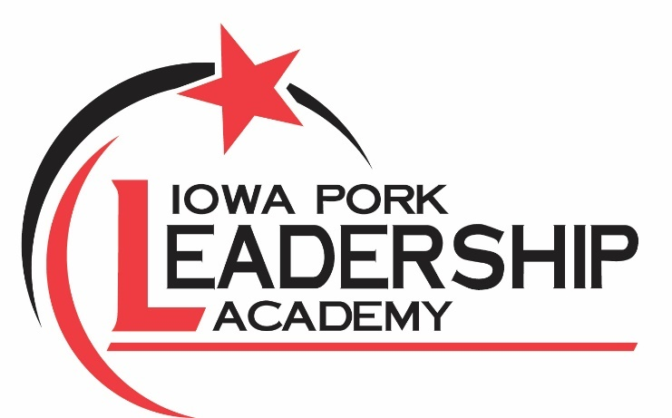

2024 Iowa Pork Leadership Academy
Applications due to Cory Van Gilst no later than Nov. 24, 2023. Please email or scan
to cvangilst@iowapork.org OR mail to the Iowa Pork Producers Association (1636 N.W. 114th St. Clive, IA 50325). Call 515-225-7675 with any questions.

Reminder: The Iowa Pork Leadership Academy is geared toward working professionals involved in pork production. Students at the high school and college levels are welcome to be involved with Iowa Pork through our internships, youth team, and scholarships.

Please type or print clearly

Name:
Address:

County :
Cell Phone: Email:

What is your involvement within pork production? (wean to finish, breed to wean, feeder to finish, etc., or allied industry)

How many head are marketed each year?

Are you a member of the Iowa Pork Producers Association?

Describe your past and current involvement with the Iowa Pork Producers Association.

Describe your involvement with other community and agriculture activities.

As you think about pork production in the next five to 10 years, what do you feel will be the most critical issues?

How do you think you might become more involved in facing those issues?

Why do you want to participate in the Iowa Pork Leadership Academy? What do you hope to gain? What skills would you like to develop?

How did you hear about this program?

The 2024 Iowa Pork Leadership Academy will meet four times throughout the year, and participants will be recognized at the 2025 Iowa Pork Congress Master Pork Awards Banquet. Being able to attend all sessions is expected. We understand the time demands of those working in the pork industry, but full participation ensures the best experience for you and your classmates. By signing below as an applicant, you acknowledge your commitment to the program and intent to attend all sessions to the best of your ability.

Signature:

If you are aware of sessions you will miss due to prior established circumstances, please indicate as such below.

Feb. 13–14, 2024 (Clive)
March 19–20, 2024 (Clive)
July 15–18, 2024 (Washington DC)
Sept. 3–6, 2024 (North & South Carolina)
Jan. 22, 2025 — Iowa Pork Congress (Des Moines)

